YSF20型Ф80压力释放阀说明书
YSF20 type Ф80 pressure release valve manual
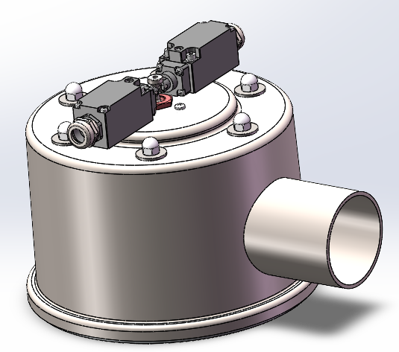
一．产品简介(Product introduction)
YSF20型Ф80压力释放阀为机车变压器和油浸式变压器用压力释放阀，当变压器油箱内部压力因事故急剧升高时，此压力如不及时释放，将造成油箱变形甚至爆裂。压力释放阀可在油箱压力升高到其开启压力值时，立即开启，使油箱内的压力迅速降低。当压力降到压力释放阀的关闭压力值时，压力释放阀可以立即关闭，使油箱内部永远保持正压，有效地防止外部空气、水份及其他杂质进入油箱。带定向喷油装置的压力释放阀（以下简称定向压力释放阀）可将所压力释放的变压器油定向喷出，并经导油管导入集油池，防止变压器油飞溅，以满足防火及环保要求。
The YSF20 type Ф80 pressure relief valve is a pressure relief valve for locomotive transformers and oil-immersed transformers. When the internal pressure of an oil-immersed power transformer's oil tank rises sharply due to an accident, if this pressure is not released in time, it will cause the oil tank to deform or even burst. The pressure relief valve can open immediately when the oil tank pressure rises to its opening pressure value, rapidly reducing the pressure inside the oil tank. When the pressure drops to the closing pressure value of the pressure relief valve, it can close immediately, keeping the oil tank's internal pressure positive at all times and effectively preventing external air, moisture, and other impurities from entering the oil tank. The pressure relief valve with a directional oil spray device (hereinafter referred to as the directional pressure relief valve) can spray the released transformer oil in a specific direction and guide it through an oil pipe into a collection pool, preventing the transformer oil from splashing and meeting fire prevention and environmental protection requirements.
二．型号、规格、结构、特点(Model, specification, structure, characteristics)
2.1、型号及说明(Model and description)
YSF □-□/□ □
环境条件、特殊说明*
Environmental conditions, special instructions
有效喷油口径(mm) Effective fuel injection diameter
开启压力(kPa) Opening pressure
结构Structure
压力释放阀代号 Pressure relief valve code
*说明：YSF-表示压力释放阀，20-表示压力释放阀的设计序号，D-表示带定向喷油，K-表示带单电气信号， SK-表示带双路电气信号，J-表示带机械信号，TH-表示用于湿热带地区。
*Description: YSF - indicates pressure relief valve, T - indicates the structure of pressure relief valve, D - indicates with directional oil injection, K - indicates with single electrical signal, SK - indicates with dual electrical signals, J - indicates with mechanical signal, TH - indicates for use in humid and tropical regions, B - indicates with locking device.
标注实例：YSF20-100/80DSKJTHB，即为第20次设计，开启压力为100kPa，喷油口径为Φ80mm，带定向喷油，带双路电气报警信号，带机械报警装置，湿热带地区用的压力释放阀。
Marking example: Model: YSFT-100/80DSKJTHB. Structure: T-type valve. Opening pressure: 100 kPa. Nozzle diameter: Φ80mm. Equipped with directional oil spraying, dual electrical alarm signals, mechanical alarm device, suitable for humid and tropical regions, and locking device. Pressure relief valve.
使用范围(Use range)：
(a). 安装位置：油箱盖顶部或油箱侧壁上；(b). 环境要求：-30℃～+70℃（可根据客户需求定制最高可支持-45℃～+70℃）; 工作环境要求：-30℃～+115℃（可根据客户需求定制最高可支持-45℃～+70℃）;
(c). 相对湿度：+20℃时，不大于95%；(d).防护等级：IP56；(e).工频耐压：2000V，1min；(f).绝缘性能：2500V，1000MΩ。
(a). Installation position: On the top of the fuel tank cap or the side wall of the fuel tank; (b). -30℃ to +70℃ (customizable to support up to -45℃ to +70℃ as per customer requirements); Working environment requirements: -30℃ to +115℃ (customizable to support up to -45℃ to +70℃ as per customer requirements).
(c). Relative humidity: no more than 95% at +20 °C; (d). Degree of protection: IP56; (e). Power frequency withstand voltage: 2000V, 1min; (f). Insulation performance: 2500V, 1000MΩ.
2.2信号开关接线图及电气参数(Signal switch wiring diagram and electrical parameters):
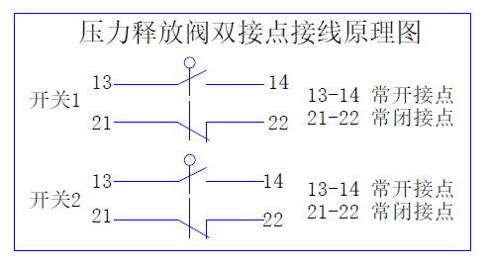
-表1- -Table 1-

电源种类  Power type | 电压(V)  Voltage | 电流A  Current
AC | 250V | 3
DC | 250V | 0.4

表1信号开关基本参数
Table 1 signal switch basic parameters
图1 双接点压力释放阀接线原理图
Figure 1 double contact pressure
reliefvalve wiring schematic diagram

2.3、性能参数（参见表2）Performance parameters (see Table 2)
单位(unit)：mm -表2- -Table 2-

有效口径（mm）Effective caliber | Φ80
开启压力（kPa）Opening pressure | 100
极限偏差（kPa）limit deviation | ±10
关闭压力（kPa）Closing pressure | ≥54
密封压力（kPa）Sealing pressure | ≥60
2.4 、特点(Characteristics)：
2.4.1、Φ80mm口径压力释放阀特点：采购IP67防水行程开关，安全可靠性高，防止意外磕碰损坏及因雨雾误报警，采用不锈钢外壳，三防性能好。
2.4.1、Φ80mm caliber pressure release valve features: purchase IP67 waterproof travel switch, high safety and reliability, prevent accidental bump damage and false alarm due to rain and fog, stainless steel shell, good three-proof performance.
2.5、外形及安装尺寸图(Shape and installation dimension drawing)
2.5.1、喷油口径为Φ80mm带电气信号且带定向喷油口，螺栓联接压力释放阀见图2;
2.5.1、The fuel injection diameter is Ф80 with electrical signal and with directional injection, bolt connection pressure relief valve shown in Figure 2;
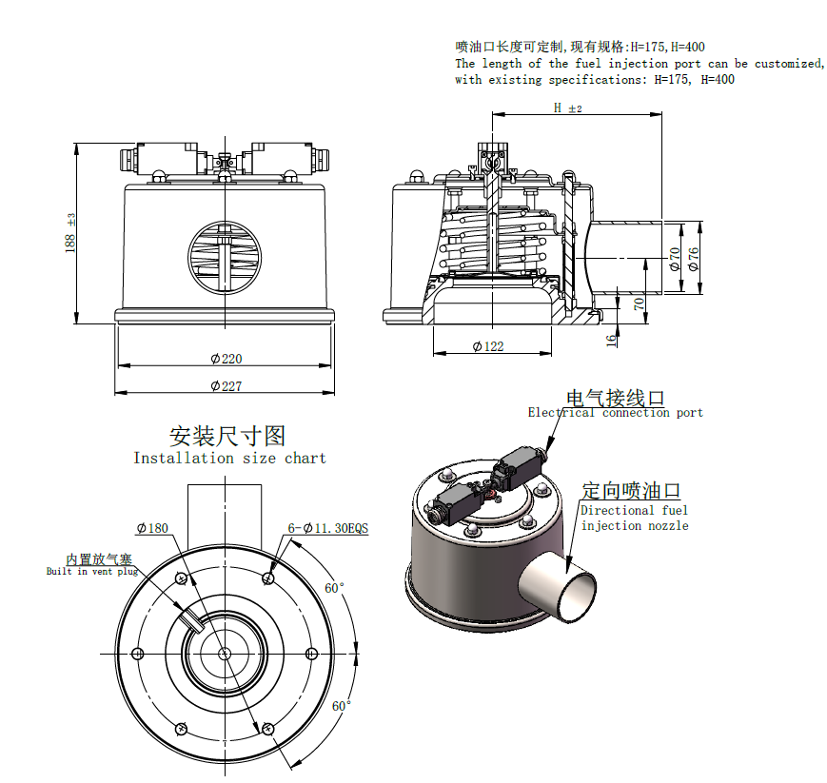

图2 YSF20 型定向喷油压力释放阀外形图
Figure 2 Outline drawing of YSFT directional injection pressure relief valve

三、安装与使用(Installation and use)
3.1、压力释放阀在箱体侧面安装，压力释放阀密封面平行于箱体焊接法兰。
3.2、用户自备6套安装螺丝、标准型弹性垫圈及平垫圈、密封胶垫，螺栓长度根据变压器箱体是的法兰安装孔螺纹深度及阀体法兰厚度（16mm）选取。
3.3、用扳手旋松阀罩上的6枚M8盖形螺母，，取下6个盖型螺母和垫片，然后取下阀座。
3.4、安装顺序：密封胶垫-阀座-6套安装螺栓固定-回装阀罩-6枚盖型螺母固定。
注意：阀座安装前确保阀体与变压器安装法兰之前的密封面无杂质。
3.5、压力释放阀的闭锁装置锁紧状态时可承受油箱内0.2MPa压力而不动作,即对变压器油箱进行油压试验时压力释放阀无需拆除。
3.6、压力释放阀在投运前必须将闭锁装置卸下，紧固闭锁装置的螺钉拆除后锁回原位安装，保证其可靠报警。
3.7、运行中的压力释放阀动作后，应将压力释放阀的机械电气信号手动复位即可解除警报。
3.8、产品出厂前已整定合格，用户不可随意拆卸。
3.9、压力释放阀信号开关的连接及电气参数（见图1、表1）,本产品可配置两套相同的独立报警电气信号开关，其中一套可用于计算机管理系统。
3.1 The pressure relief valve is installed on the side of the box, and the sealing surface of the pressure relief valve is parallel to the welding flange of the box.
3.2 The user shall prepare 6 sets of installation screws, standard elastic washers and flat washers, and sealing gaskets. The length of the bolts shall be selected according to the depth of the threaded holes of the flange on the transformer box and the thickness of the valve body flange (16mm).
3.3 Loosen the 6 M8 countersunk nuts on the valve cover with a wrench, remove the 6 countersunk nuts and washers, and then remove the valve seat.
3.4 Installation sequence: sealing gasket - valve seat - 6 sets of installation bolts - reinstall the valve cover - 6 countersunk nuts.
Note: Before installing the valve seat, ensure that there is no impurity on the sealing surface between the valve body and the transformer installation flange.
3.5 When the locking device of the pressure relief valve is in the locked state, it can withstand a pressure of 0.2 MPa in the oil tank without action. That is, when conducting an oil pressure test on the transformer oil tank, the pressure relief valve does not need to be removed.
3.6 Before putting the pressure relief valve into operation, the locking device must be removed. After removing the screws that fix the locking device, reinstall them in their original position to ensure reliable alarm.
3.7 After the pressure relief valve in operation acts, the mechanical and electrical signals of the pressure relief valve can be manually reset to clear the alarm.
3.8 The product has been set and qualified before leaving the factory. Users are not allowed to disassemble it at will.
3.9 The connection and electrical parameters of the pressure relief valve signal switch (see Figure 1, Table 1). This product can be equipped with two sets of the same independent alarm electrical signal switches, one of which can be used for the computer management system.

四、常见问题及处理方法(Common problems and treatment methods)

故障现象Fault phenomenon | 故障原因  Cause of the problem | 解决方法  Solution
压力释放阀漏油  Pressure relief valve leakage | 变压器呼吸器阀门未打开，箱体内部气体受热膨胀，导致压力超过释放阀密封压力；  Transformer breather valve is not opened, chamber gas heat expansion, cause stress over pressure release valve seal; | 打开呼吸器阀门；  Open the scuba valves;
压力释放阀漏油  Pressure relief valve leakage | 密封圈的密封面上有异物  A foreign body sealing ring sealing surface | 将异物取出；  Will foreign body removal;
压力释放阀漏油  Pressure relief valve leakage | 阀运行期长，胶圈老化失效  The valve operating period is long, aprons aging failure | 利用设备停电进行检修，更换密封圈；  Using equipment power outage for maintenance, replacement of sealing ring;
压力释放阀漏油  Pressure relief valve leakage | 零部件受外力变形或损坏  Deformation or damage to the parts by external forces | 更换整套压力释放阀；  Replacement of a complete set of pressure relief valve;
压力释放阀漏油  Pressure relief valve leakage | 油箱内部压力长期处于阀的密封压力与阀的开启压力之间，造成渗漏，此种情况非常稀少  Inside the tank pressure valve for a long time between the sealing pressure and valve opening pressure, causing leakage, such things are very few | 检查变压器内部有何不良现象，消除隐患即可  What is the bad check transformer internal phenomenon, eliminate hidden dangers
信号开关无控制信号输出  Signal switch control signal output | 电气线路连接异常或解除不良及开路现象  Electrical wiring connection exception or remove bad and open circuit phenomenon | 按信号开关的连接图进行正确连线；  用万用表或摇表测量线路连接点间接触是否良好；  According to the connection diagram of signal switch correct attachment;  Measured with a multimeter or shaking table line contact between points are in good condition;
信号开关无控制信号输出  Signal switch control signal output | 信号开关有卡滞、堵塞现象  Signal switch is binding, blocking phenomenon | 上下拉动阀的小红帽，检查开关动作是否灵敏，同时测量开关有无信号输出；  Pull up and down the little red riding hood, check whether the switch action is sensitive, measuring switch presence of signal output at the same time;
阀不动作  Valve is not action | 阀的闭锁装置未拆除；  Valve lock has not torn down; | 将闭锁装置拆除即可；  Remove the locking device;
阀不动作  Valve is not action | 油箱压力未达到阀的开启压力；  Tank pressure does not reach the valve opening pressure; | 用压力表检测油箱压力是否达到阀的开启压力；  Pressure gauge is used to inspect whether achieve valve opening pressure tank pressure;
阀不动作  Valve is not action | 油箱及阀有漏气部位；  Fuel tank and the leak valve parts | 检测油箱及阀密封是否良好；  Test tank and valve seals are in good condition;

五．承诺(commitment)
用户单位在使用本产品时要按说明书进行操作，本产品在安装之日起18个月内，并在公司发货给用户不超过24个月的期限内，我公司对产品实行三包。
The user unit shall operate according to the instructions when using this product. Within 18 months from the date of installation, and within the period of delivery of the company to the user for no more than 24 months, our company implements three guarantees for the product.

沈阳德广电气科技有限公司
Shenyang Deguang Electricity Technology Co., Ltd.
地 址：沈阳市浑南新区祥瑞工业园2号
Add: No.2 Xiangrui Industrial Park,Hunnan New District,Shenyang City
邮 编Postcode：110168 邮 箱 E-mail：info_dgdq@126.com
电 话Tel：024-23825580 传 真Fax：024-23825590

